# *GPU process - detailed architecture overview*

[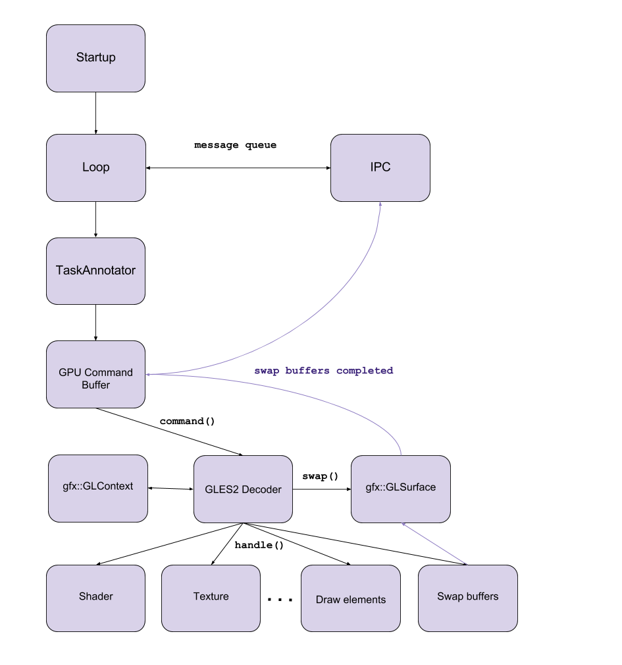](https://docs.google.com/drawings/d/11zKL9vphVV5aFMaAHZO3NrvxI7BxVY08cwXSC6OmYq4/edit?usp=sharing)

* **Startup**
  + the entry point for the GPU process
* **Loop**
  + MainMessageLoop
    - is used to process events for a particular thread
    - puts the incoming messages, tasks to a queue
    - pops a task from the queue and starts it
    - strong relationship with the IPC communication framework
    - has task reentrancy protection
      * second task cannot be started until first task finishes
* **IPC**
  + framework which is used for inter-process communication
  + connects directly to the MainMessageLoop
  + provides communication channels through which the messages can be sent
  + message creating, sending and receiving
  + asynchronous message handling
* **TaskAnnotator**
  + all incoming tasks are going through a TaskAnnotator which annotates the task before the execution
  + implements common debug annotations for posted tasks. This includes data such as task origins, queueing durations and memory usage
  + runs a previously queued task
* **GPU Command Buffer**
  + implements IPC methods (Receive, Send)
  + handles messages (Set/Get buffer, Flush, Create/Destroy Images, etc) and sends commands
* **gfx::GLSurface**
  + encapsulates a surface that can be rendered to with GL, hiding platform specific management
* **gfx::GLContext**
  + encapsulates an OpenGL context, hiding platform specific management
* **GLES2 Decoder**
  + decodes GLES2 commands from Command Buffer
  + calls GL methods
* **Shader, Texture, …, Draw elements**
  + calls actual OpenGL functions
  + compiles and executes shader codes
  + manipulates textures (bind, remove, setTarget, etc)
  + other calls manage the GLContext’s state
* **Swap buffers**
  + handles frame swaps
  + if the buffer is offscreen then it copies the rendered frame to another framebuffer

Sources:

<https://code.google.com/p/chromium/codesearch#chromium/src/base/message_loop/message_loop.h>

<https://code.google.com/p/chromium/codesearch#chromium/src/base/debug/task_annotator.h&q=task_annotator&sq=package:chromium&type=cs&l=1>

<https://code.google.com/p/chromium/codesearch#chromium/src/cc/raster/task_graph_runner.h&q=taskgraph&sq=package:chromium&type=cs&l=42>

<https://code.google.com/p/chromium/codesearch#chromium/src/content/common/gpu/gpu_command_buffer_stub.h&q=gpucommandbufferstub&sq=package:chromium&type=cs&l=92>